Question 3

Answer:

From the encrypt(text,key) function, we can find that ord(char) will turn char into ASCII number and shift the char backward by the number of key. For example, if k=3, char ‘A’ will shift backward in ASCII and become “D”. If we shift the char in the reverse direction by key number which means shift char forward, we can get the decryption function which is shown in the following and in the decrypt.py. The importance in decrypt(text, key) is to “shifted = ord(char) - key” and we can shift char backward. Meanwhile, we use the code in image 1 to get total number is 13. Thus, the key is 13 as well. Now, we have the decrypt function.

Next, we can load encrypted code which is stored in the encrpted_code.txt into decrypt() function by with open() method and file.read() method. This code is also shown in the following part and the decrypt.py file. By running decrypt.py and decrypt(text,key) function, we can get decrypted code which is stored in the decrypted_code.py file.

The errors in the decrypted_code.py is shown in the following and in the decrypted_code_modified.py file.

1. Accord to result=process_numbers(numbers=my_set), the process_numbers() need a parameter. Therefore, we add numbers into process_numbers(). Def process_numbers(numbers) function is used to remove even elements from my_set.
2. The parameter 5 in modify_dict(5) is meaningless because def modify_dict() doesn’t use external parameter.
3. def update_global() is defined but isn’t called in the original code. This function is meaningless unless we call it. Thus, we add update_global() to call def update_global().

After modification on decrypted_code.py, we can get decrypted_code_modified.py. By running this code, we can get the result shown in the following.

Image 1:

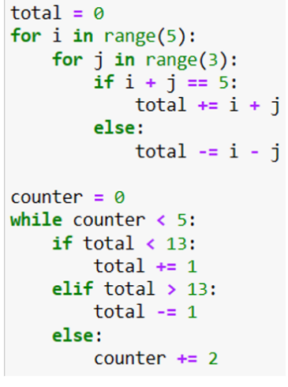

decrypt.py:

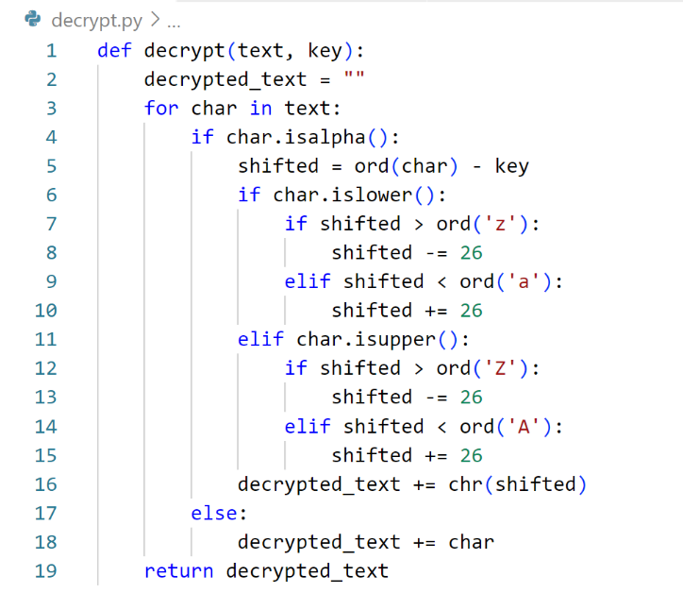

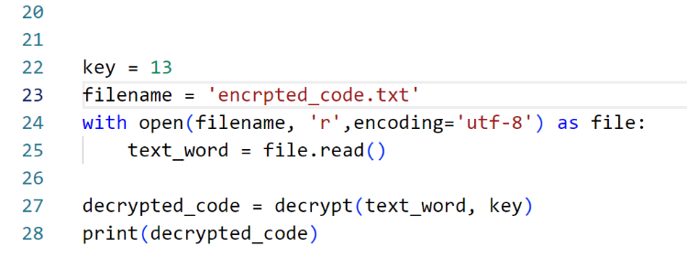

decrypted_code.py:

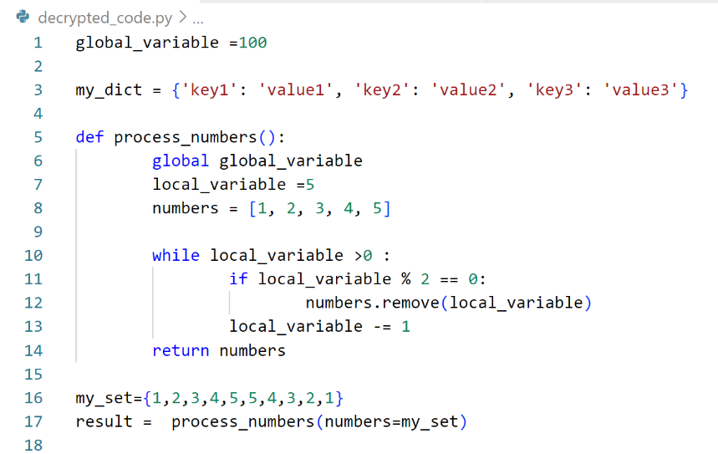

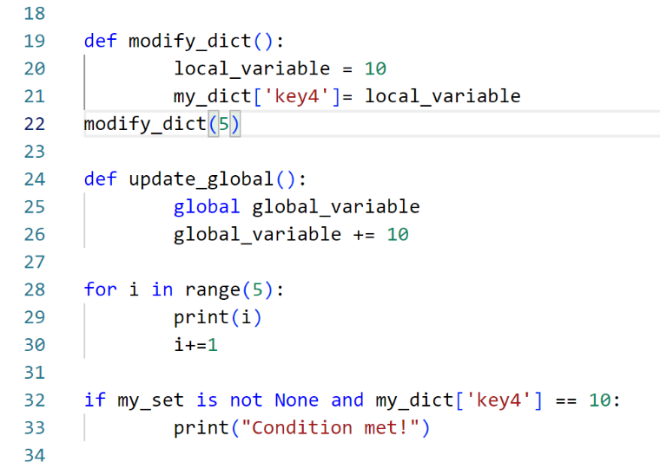

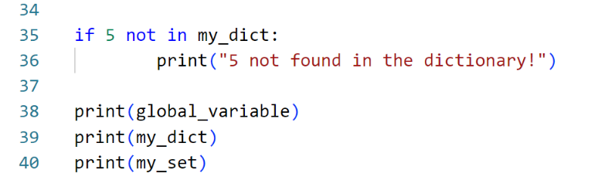

Decrypted_code_modified.py

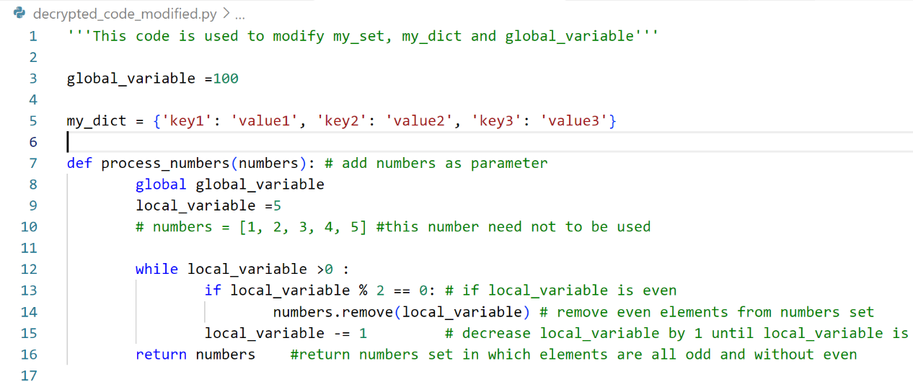

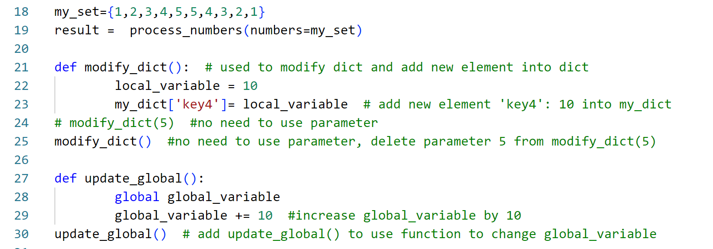

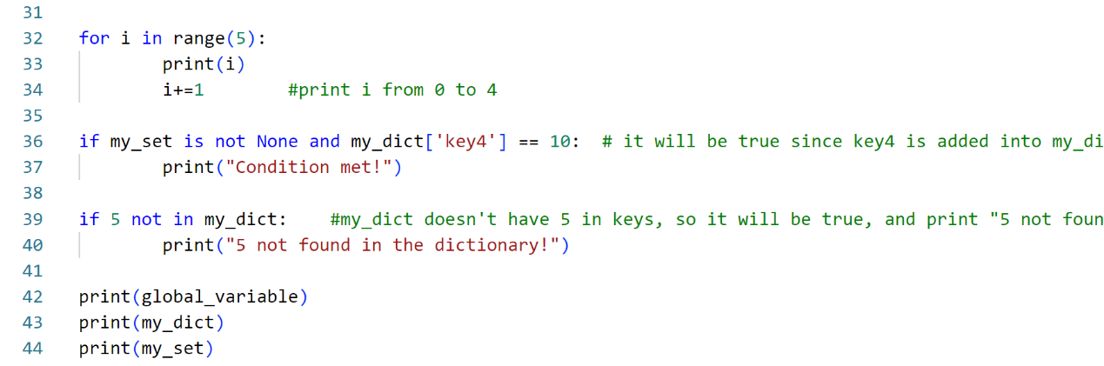

The result is:

0

1

2

3

4

Condition met!

5 not found in the dictionary!

110

{'key1': 'value1', 'key2': 'value2', 'key3': 'value3', 'key4': 10}

{1, 3, 5}